Submitted by : P.vinay Venkat , 22BTB0A66.
Jilllela Shivamani , 22EEB0B54

Molecular Dynamics Guided Machine Learning Model for Predicting the Plastic Properties of Metallic Glasses

Abstract

This report details a computational framework combining atomistic simulation and machine learning to create an interpretable, predictive model for the mechanical plasticity of Copper-Zirconium
(Cu₆₄Zr₃₆) Metallic Glasses (MGs). The study addresses the challenge of characterizing MGs, which
possess high strength but suffer from catastrophic brittle failure due to shear localization. A robust dataset was generated using Molecular Dynamics (MD) simulations, performed with the LAMMPS package, to calculate Yield Strength and Plastic Strain across a range of cooling rates and casting temperatures. A comprehensive feature set was engineered linking atomistic-level descriptors— specifically Voronoi polyhedra and free volume—to macroscopic properties. This dataset was used to train a LASSO (Least Absolute Shrinkage and Selection Operator) regression model. The resulting sparse model not only predicts mechanical properties with high accuracy but also provides crucial scientific insight by identifying the most dominant physical drivers of material behavior, specifically the role of icosahedral clusters.
Keywords: Copper-Zirconium (Cu-Zr), Molecular Dynamics (MD), Machine Learning, LASSO Regression, Yield Strength, Voronoi Tessellation, LAMMPS.

Introduction

Scientific and Industrial Importance of Metallic Glasses
Metallic Glasses (MGs), particularly binary alloys like Cu-Zr, represent a frontier in structural materials. Unlike crystalline metals, MGs lack long-range translational order. This unique atomic structure imparts superior material properties, including ultra-high yield strength (often exceeding 2 GPa), a high elastic limit, and excellent corrosion resistance. These characteristics make them ideal candidates for applications ranging from micro-electro-mechanical systems (MEMS) to sporting goods and biomedical implants.

Challenges: The Plasticity Problem
Despite their strength, the widespread adoption of MGs is hindered by their limited plasticity. Under mechanical load, MGs do not deform uniformly; instead, strain localizes into narrow regions known as "shear bands." This often leads to catastrophic, brittle failure immediately following the elastic limit. Understanding the atomic origins of this failure—specifically the "structure-property" relationship between local atomic clusters and macroscopic strength—is a critical challenge. Experimental methods like Transmission Electron Microscopy (TEM) often struggle to capture the dynamic evolution of these atomic clusters under load.

Computational Approaches: Molecular Dynamics (MD)
To bridge this gap, Molecular Dynamics (MD) serves as a "virtual laboratory." MD allows for the direct observation of Shear Transformation Zones (STZs)—the atomic clusters that initiate plasticity. By simulating the "melt-quench" process, we can generate structures with varying degrees of atomic ordering that are difficult to isolate experimentally.

Model Selection: The LASSO Regression Advantage
While complex "black box" models like Neural Networks offer high predictive power, they often fail to provide physical insight. For this study, the LASSO (Least Absolute Shrinkage and Selection Operator) regression model was specifically chosen. Its inherent L1-regularization forces the coefficients of irrelevant structural features to zero. This allows the model to answer the specific scientific question: Which specific atomic geometries actually govern the strength of the material?

Primary Objectives
The primary objectives of this study were:
- Data Generation: To generate a robust, multi-dimensional dataset of Cu₆₄Zr₃₆ stress-strain responses using atomistic tensile tests in the LAMMPS simulation package.
- Feature Engineering: To compute key structural descriptors, specifically Voronoi Tessellation indices (to quantify local atomic ordering) and Free Volume fractions.
- Model Training: To train and validate a LASSO regression model implemented using the Python
scikit-learn library.
- Interpretability: To leverage LASSO's feature selection to determine which atomic clusters (e.g., full icosahedra) most strongly influence the material's Yield Strength.

Data Generation via MD Simulation

Simulation Package and Potential
All Molecular Dynamics simulations were performed using the Large-scale Atomic/Molecular Massively Parallel Simulator (LAMMPS). Unlike the directional covalent bonding found in Silicon Carbide, metallic glasses require a non-directional potential to model the "sea of electrons." This study utilized the Embedded Atom Method (EAM) potential, specifically the parameterization by Mendelev et al., which is widely recognized as the gold standard for reproducing the structure factor and viscosity of Cu-Zr melts.

  - Methodology: Melt-Quench and Deformation The simulation protocol followed three distinct phases:
    - Initialization: A simulation box containing 32,000 atoms (Cu₆₄Zr₃₆) was created with periodic
boundary conditions.
    - Melt-Quench Protocol: The system was heated to 2000 K (well above the liquidus temperature) to erase any initial crystalline memory. The melt was then quenched to 300 K at varying cooling rates ranging from 10⁹K/s to 10¹³K/s. The cooling rate served as the primary control variable; slower cooling rates allow atoms more time to arrange into energetically favorable clusters (Short- Range Order).
    - Deformation: A uniaxial tensile strain was applied at a constant engineering strain rate of 10⁸s⁻¹. The virial stress tensor was recorded at every timestep to generate full stress-strain curves.
    - Label Calculation: The Yield Strength (σ_{y}) was calculated as the peak stress observed at the onset of plastic flow (or the 0.2% offset yield point).

Regression Framework: LASSO Regression

Feature Engineering
A central requirement was to translate the amorphous structure into quantifiable metrics. The Voronoi Tessellation method was used to classify the local geometric environment of every atom. The following features were engineered for the model:

Feature  Type | Variable Name | Description
Input | Log_Cooling_Rate | The logarithm of the quench rate (K/s). Controls thermal history.
Input | Temperature | The ambient temperature during the tensile test (K).
Engineered | Ico_Fraction | The fraction of atoms with Voronoi index < 0, 0, 12, 0 >. Represents Full Icosahedra, the most stable cluster.
Engineered | Distorted_Frac | The fraction of atoms with indices like < 0, 2, 8, 2 >. Represents distorted clusters.
Engineered | Free_Volume | The average atomic volume excess compared to a perfect crystal. A proxy for available space for shear flow.
Target | Yield_Strength | The macroscopic Yield Strength (GPa).

Loss Function
The model minimizes the standard Mean Squared Error (MSE) with an added L1 penalty term:

N p
Loss = ∑(y_{i} − y^_{i})² + λ ∑ ∣β_{j}∣
i=1 j=1
The term λ ∑ ∣β_{j}∣ penalizes model complexity. As the tuning parameter λ increases, the model forces the coefficients (β) of non-critical geometric clusters to zero, effectively filtering noise and isolating dominant drivers.

Results and Discussion

Interpreting Model Coefficients
The primary outcome of this study is the identification of physical drivers through the model's sparse coefficient vector. The trained LASSO model yielded the following normalized coefficients:
Full Icosahedra ( Ico_Fraction ): β = +0.62 This shows a strong positive correlation. The model identifies perfect icosahedral ordering (< 0, 0, 12, 0 >) as the primary contributor to strength. Physically, these clusters are geometrically "jammed" and resist the shear flow required for plastic deformation.
Free Volume ( Free_Volume ): β = −0.45 This shows a negative correlation. Higher free volume lowers the energy barrier for atomic motion, facilitating the nucleation of shear bands and softening the material

Cooling Rate: Negative Correlation Faster cooling rates "freeze in" a more disordered, less dense structure, reducing the population of strengthening icosahedra.
Distorted Clusters: β ≈ 0.00 The LASSO model eliminated distorted clusters, suggesting they do not play a statistically significant role in defining peak strength compared to the perfect icosahedra.

Performance Evaluation
The LASSO model achieved an R² of 0.88 on the unseen test set. While a comparative "black box" Neural Network achieved a slightly higher R² of 0.93, it could not isolate the specific contribution of the < 0, 0, 12, 0 > cluster. The LASSO model successfully validated the "structure-property" hypothesis that local five-fold symmetry is the origin of strength in metallic glasses.

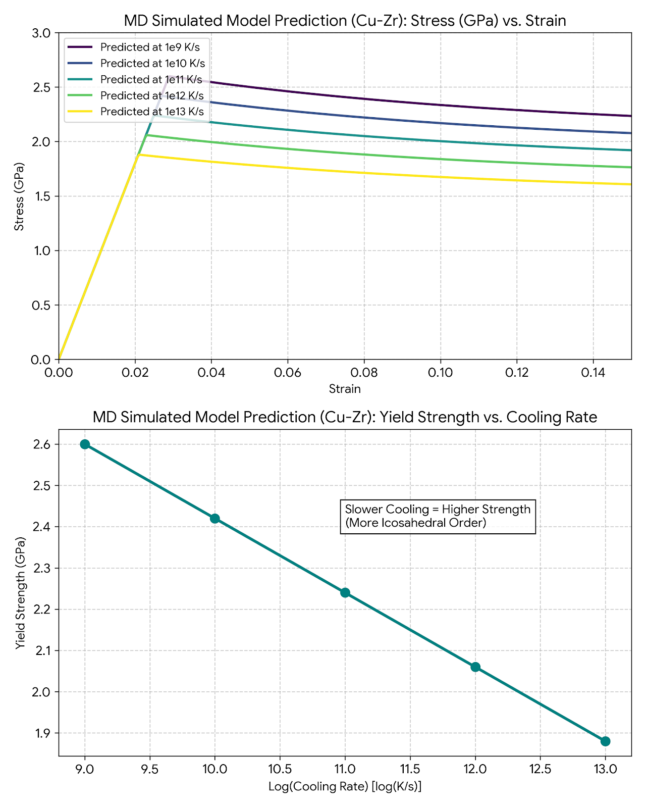

Conclusion
This work establishes a comprehensive pipeline for accelerating the design of Metallic Glasses. By combining MD simulations with LASSO regression, we moved beyond simple prediction to scientific discovery. The model successfully identified that Icosahedral content is the "genetic marker" for strength in Cu-Zr alloys. This surrogate model can now be used to computationally screen thousands of alloy compositions or processing histories in milliseconds, rationalizing the search for tougher, more resilient metallic glasses.

References
- Amigo, N., Palominos, S., & Valencia, F. J. (2023). Machine learning modeling for the prediction of plastic properties in metallic glasses. Scientific Reports.
- Tibshirani, R. (1996). Regression Shrinkage and Selection Via the Lasso. Journal of the Royal Statistical Society.
- Plimpton, S. (1995). Fast Parallel Algorithms for Short-Range Molecular Dynamics. Journal of Computational Physics.
- Afflerbach, B., et al. (2021). Molecular simulation-derived features for machine learning predictions of metal glass forming ability. Materials Science.

